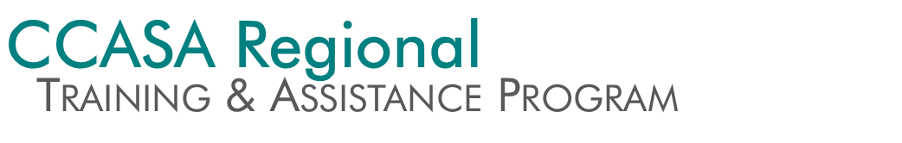
CCASA is Recruiting Regional Specialists!

CCASA’s new Regional Training & Assistance Program (RTAP) is seeking applications for Regional Specialists with expertise in sexual assault victim/survivor advocacy. Five Regional Specialists from CCASA member agencies will be selected as contractors in summer 2014 to provide ongoing training and technical assistance within their membership region and statewide.

Regional Specialists will participate in a train-the-trainer program provided by CCASA staff and partners, and they will be representing CCASA—not their agency—when providing training and technical assistance through this program. Frequency of training and assistance provided by each Regional Specialist will be determined by CCASA staff. This contracted position is not meant to replace or supplement hours already being worked at a CCASA member agency.

Qualified applicants will have both regional experience as well as experience within a specific area of service provision (i.e. serving survivors with developmental disabilities, SART development, advocacy to Spanish-speaking survivors, support groups, etc.).

Qualified applicants will have a minimum of three-five years of experience providing direct service sexual assault advocacy as well as experience providing instruction, conducting training and/or presenting on sexual assault, victim advocacy or related victim issues.

Qualified applicants must complete and pass a criminal history check, and will participate in an interview and selection process. Selected individuals will be offered a contract with CCASA to provide paid services. Instructors are paid at a rate of $50/hour for training delivery, $20/hour for preparation, planning, and travel. CCASA anticipates that Regional Specialists will be needed for approximately 30 hours during the remaining 2014 calendar year.

About RTAP
Colorado is a large and diverse state. Recognizing the need for tailored and community-specific technical assistance, the CCASA Regional Training & Assistance Program is designed to leverage victim/survivor advocates within Colorado communities in order to provide on-the-ground, in-person training and technical assistance to CCASA members while elevating the statewide advocacy expertise beyond the coalition.

How Communities Benefit
CCASA member agencies across the state will benefit from direct support from CCASA Regional Specialists working in the victim/survivor advocacy field in Colorado. Service providers can contact the Regional Specialists for consultation on a specific issue or case or to facilitate CCASA-sponsored training in their region or at their agency.

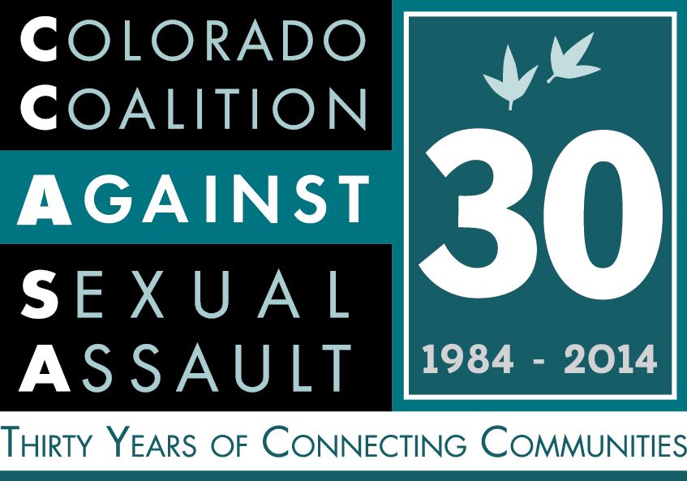
Learn More
Contact Alexa Priddy, Director of Training & Communications, at
outreach@ccasa.org or 303.625.9564 for more information about the CCASA Regional Training & Assistance Program or to apply to be a Regional Specialist. Completed applications must be emailed to Alexa by Monday, July 7th at 5pm. Visit ccasa.org/rtap.
Regional Specialist Application

Please be sure to include all of the requested materials and answer all of the short answer and essay questions. All application materials should be typed and submitted via email. Incomplete applications will not be considered. Applicants must be available for the RTAP Train-the-Trainer for 3 days during the week of October 13-17, 2014.

- Resume or Curriculum Vitae
- Please be sure that your resume includes:
- Full name
- Address, Phone, and Email
- Current work contact information
- CCASA region in which you work
- Professional references (3-5)
- Relevant work experience (include agency name, address, and phone) with your position title and the number of years at that position.
- Relevant education

- Short Answer
- How long have you worked in victim/survivor advocacy and, specifically, direct service sexual assault advocacy?

- Please list any additional relevant sexual assault work experience.

- Please list any training or instruction that you have provided in the last five years. Be sure to include:
- Topic
- Date
- Audience composition and number
- Location

- Please list your participation or relationships with any advocacy organizations or relevant community groups (CCASA, Sexual Assault Response Team, professional associations, organizations, etc.) that will benefit your role as a Regional Specialist.

- Please list any specific areas of experience within direct service sexual assault victim advocacy that you would bring to the role of Regional Specialist (i.e. serving survivors with developmental disabilities, SART development, advocacy to Spanish-speaking survivors, support groups, etc.).

- Short Essays
- Please identify the critical elements of sexual assault training and why you have an interest in becoming an instructor for the CCASA Regional Training & Assistance Program (RTAP).

- What is one of the most pressing issues for victim advocates in Colorado? How have you dealt with this issue, and how would you support another advocate as they addressed this issue in their community?

Your response to each question should not exceed 500 words (approximately 2 pages) and be double spaced, 12-point font, with standard margins.

Completed applications must be emailed to Alexa Priddy, Director of Training & Communications, at outreach@ccasa.org by Monday, July 7th at 5pm.
Applicants will be contacted for interviews following this deadline.

