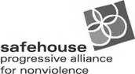 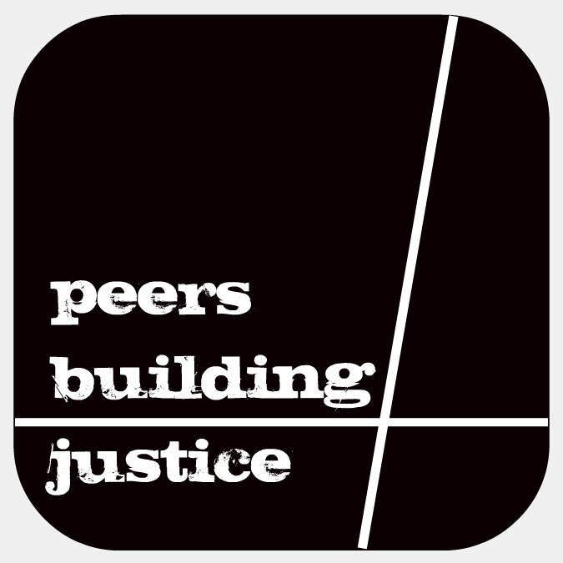 

**\*\*2014-2015 SCHOOL YEAR\*\***

(*): Are optional

Name:____________________________________*Preferred Name________________________ Address:__________________________________ City:_______________ Zip:______________

Home Phone #:_________________________Cell Phone #:_______________________________

Email:________________________________How often do you check your email?____________

School? Y N What school:____________________________Year in School:________________

Date of Birth:____/____/___ *Ethnicity:___________________*Gender Identity___________

*Sexual Orientation:______________________________________________________________

Emergency Contact (Name and #):___________________________________________________

Best/fastest way to reach you:_____________________________________________________

I’d like to be a PBJ Campus Organizer OR receive more PBJ info





**\*\*THANK YOU FOR YOUR INTEREST IN PEERS BUILDING JUSTICE!\*\***

Please respond to the following questions to the best of your ability. Please be informed that if you tell us about any personal experience with sexual assault or abusive situations, we are required by law to report this information to law enforcement and/or social services.

Once finished, return application to pbjboulder@gmail.com

1. **Why are you interested in becoming a Peers Building Justice (PBJ) Member?**
2. **Have you ever volunteered before? Yes No**

**If yes, please describe your past or current volunteer service experience.**

1. **Peers Building Justice will be planning an arts-based community project possibly involving music, art, theater, dance, poetry, film, or whatever PBJ dreams up!**
2. **What skills around event planning, organizing, or the arts do you already have? And,**
3. **(In these areas), what skills would you like to learn or develop?**

**What languages do you speak, other than English, and with what proficiency?**

**Are you available for weekend work?**

**How do you think violence against women and children is connected to all other forms of oppression such as sexism, racism, heterosexism, ableism, etc.?**

**Please list names and phone numbers of 2 references.**

1. **________________________________________________**
2. **________________________________________________**

**Briefly describe your particular interest in the following topics: Sexual Assault, Sexual Harassment, and/or dating abuse. (Note: You can pick just one or comment on all of them)**

**How do you feel speaking in front of a group?**